Step 3: Projections & Filtering
- Select specific columns (e.g., student names and emails).
select name, email from Students;
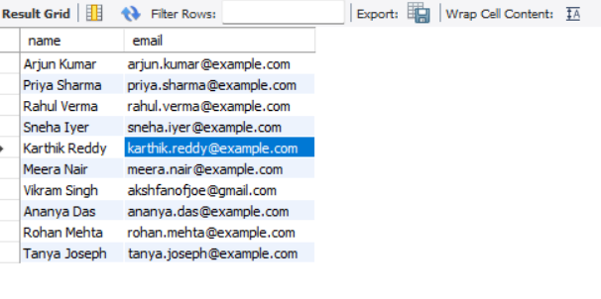
- Use arithmetic operators (e.g., calculate GPA = SUM(grade*credits)/SUM(credits)).
SELECT s.student_id,
s.name,
SUM(
CASE grade
WHEN 'A' THEN 10
WHEN 'B' THEN 8
WHEN 'C' THEN 6
WHEN 'D' THEN 4
WHEN 'E' THEN 2
WHEN 'F' THEN 0
END * c.credits
) / SUM(c.credits) AS GPA
FROM Enrollments e
JOIN Students s ON e.student_id = s.student_id
JOIN Courses c ON e.course_id = c.course_id
GROUP BY s.student_id, s.name;

- Apply DISTINCT, alias, ORDER BY.
SELECT DISTINCT semester
FROM Enrollments
ORDER BY semester;
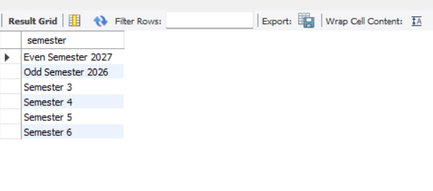
Step 4: Row Selection
- Use WHERE with comparison operators (e.g., students born after 2000).
select student_id,name,dob from students where dob >= '2005-01-01' order by dob; (For my data I used date > or = to 2005)
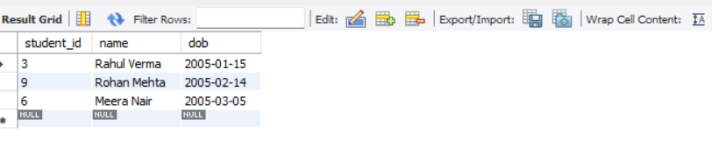

- Combine logical operators (AND, OR, NOT).
select student_id from Enrollments where (grade="A" OR course_id="101");
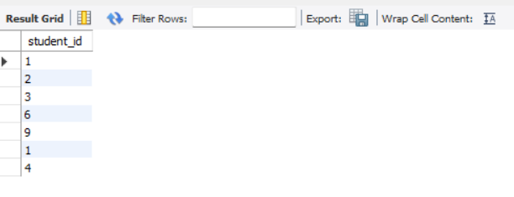
SELECT name, dob, gender
FROM Students
WHERE dob > '2000-01-01' AND gender = 'F';
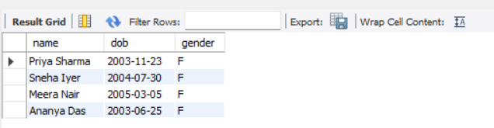
select name from Students where dob > '2005-01-01' AND gender <> 'F';
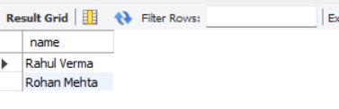
Step 5: Advanced Filtering
- Find students enrolled in courses using IN.
SELECT s.student_id, s.name, c.course_name
FROM Students s
JOIN Enrollments e ON s.student_id = e.student_id
JOIN Courses c ON e.course_id = c.course_id
WHERE c.course_name IN ('Database Systems', 'Thermodynamics');
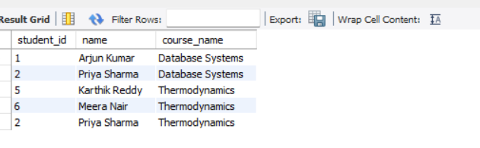
- Use LIKE to filter names starting with “R”.
SELECT s.student_id, s.name, c.course_name
FROM Students s
JOIN Enrollments e ON s.student_id = e.student_id
JOIN Courses c ON e.course_id = c.course_id
WHERE c.course_name IN ('Database Systems')
AND s.name LIKE 'P%';
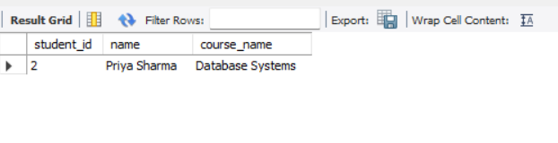
- Check for missing grades with IS NULL.
Inserted two new students. Then inserted two new enrollments with grade as null.
SELECT s.student_id, s.name, c.course_name
FROM Students s
JOIN Enrollments e ON s.student_id = e.student_id
JOIN Courses c ON e.course_id = c.course_id
WHERE e.grade is null;
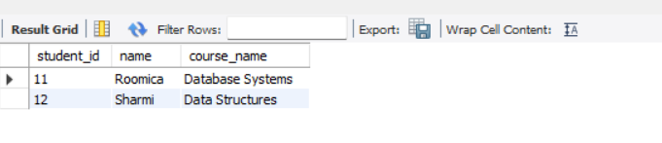
Step 6: Aggregation & Grouping
- Count students per department.
SELECT d.dept_name, COUNT(s.student_id) AS student_count
FROM departments d
JOIN Students s ON d.dept_id = s.student_id
GROUP BY d.dept_name
ORDER BY student_count DESC;
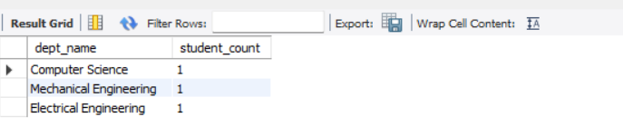
- Find average grade per course.
SELECT c.course_name, AVG(e.grade) AS average_grade
FROM Courses c
JOIN Enrollments e ON c.course_id = e.course_id
GROUP BY c.course_name
ORDER BY average_grade DESC;
/* Use UNION to combine student names from two departments */
SELECT s.name AS student_name,d.dept_name AS department
FROM Students s
JOIN Enrollments e ON s.student_id = e.student_id
JOIN Courses c ON e.course_id = c.course_id
JOIN Departments d ON c.dept_id = d.dept_id
WHERE d.dept_name = 'Computer Science'

UNION

SELECT s.name AS student_name,d.dept_name AS department
FROM Students s
JOIN Enrollments e ON s.student_id = e.student_id
JOIN Courses c ON e.course_id = c.course_id
JOIN Departments d ON c.dept_id = d.dept_id
WHERE d.dept_name = 'Mechanical Engineering'
ORDER BY department;
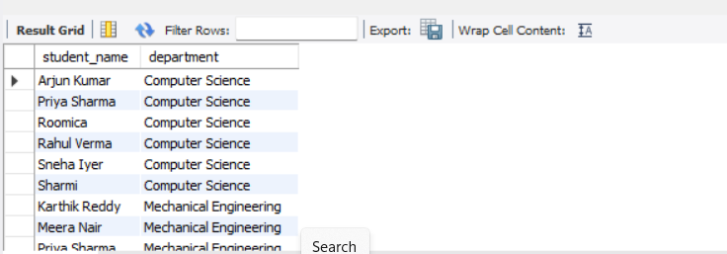
/*Apply LIMIT to show top 5 students by GPA*/
SELECT s.student_id,
s.name,
SUM(
CASE grade
WHEN 'A' THEN 10
WHEN 'B' THEN 8
WHEN 'C' THEN 6
WHEN 'D' THEN 4
WHEN 'E' THEN 2
WHEN 'F' THEN 0
END * c.credits
) / SUM(c.credits) AS GPA
FROM Enrollments e
JOIN Students s ON e.student_id = s.student_id
JOIN Courses c ON e.course_id = c.course_id
GROUP BY s.student_id, s.name
ORDER BY GPA DESC
LIMIT 5;
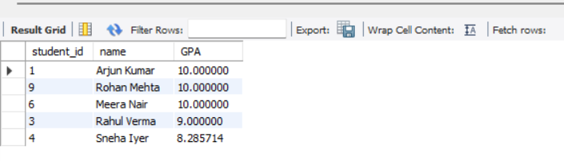
/* INNER JOIN students with enrollments */
SELECT s.student_id,
s.name,
s.email,
e.course_id,
e.semester,
e.grade
FROM Students s
INNER JOIN Enrollments e
ON s.student_id = e.student_id
ORDER BY s.student_id, e.semester;
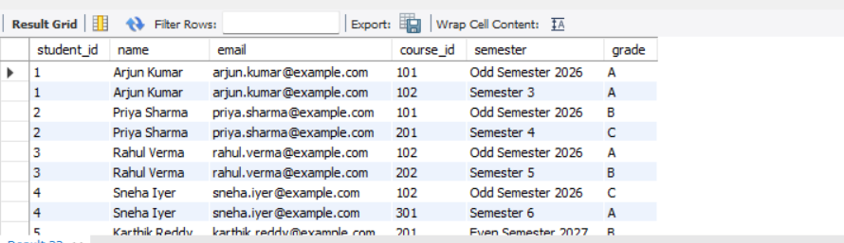
/*LEFT JOIN courses with enrollments*/
SELECT c.course_id,
c.course_name,
e.enroll_id,
e.student_id
FROM Courses c
LEFT JOIN Enrollments e
ON c.course_id = e.course_id
ORDER BY c.course_id, e.student_id;
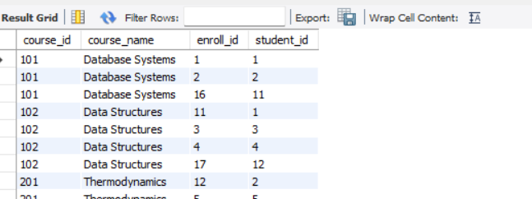
/* Find students who scored above the average grade*/
SELECT s.student_id,
s.name,
e.course_id,
e.grade
FROM Students s
JOIN Enrollments e ON s.student_id = e.student_id
WHERE
CASE e.grade
WHEN 'A' THEN 10
WHEN 'B' THEN 8
WHEN 'C' THEN 6
WHEN 'D' THEN 4
WHEN 'E' THEN 2
WHEN 'F' THEN 0
END >
(
SELECT AVG(
CASE grade
WHEN 'A' THEN 10
WHEN 'B' THEN 8
WHEN 'C' THEN 6
WHEN 'D' THEN 4
WHEN 'E' THEN 2
WHEN 'F' THEN 0
END
)
FROM Enrollments
)
ORDER BY student_id;
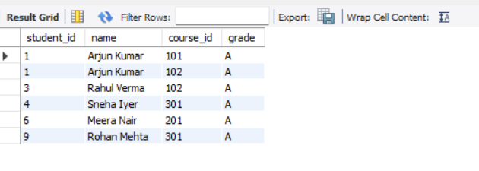
/* Apply EXISTS/NOT EXISTS to check if a student is enrolled in any course */
SELECT s.student_id,
s.name,
c.course_name
FROM Students s
JOIN Enrollments e ON s.student_id = e.student_id
JOIN Courses c ON e.course_id = c.course_id
WHERE EXISTS (
SELECT 1
FROM Enrollments e2
WHERE e2.student_id = s.student_id
);
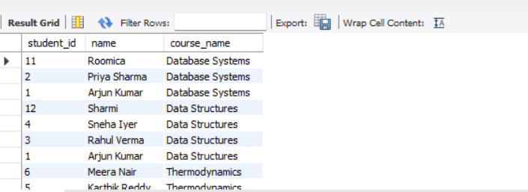
Not exists scenario
SELECT s.student_id,
s.name,
c.course_name
FROM Students s
JOIN Enrollments e ON s.student_id = e.student_id
JOIN Courses c ON e.course_id = c.course_id
WHERE NOT EXISTS (
SELECT 1
FROM Enrollments e
WHERE e.student_id = s.student_id
);
